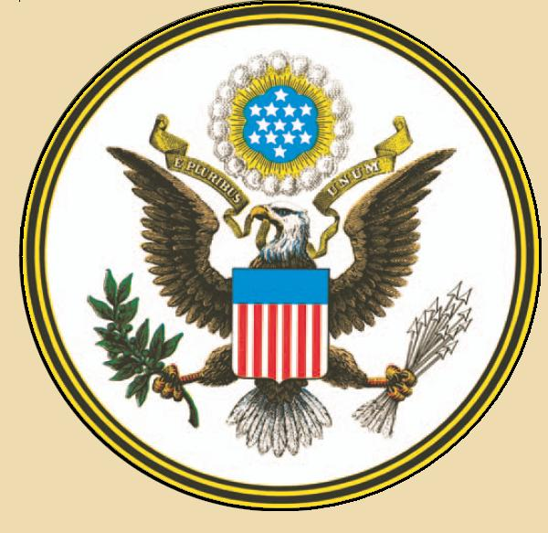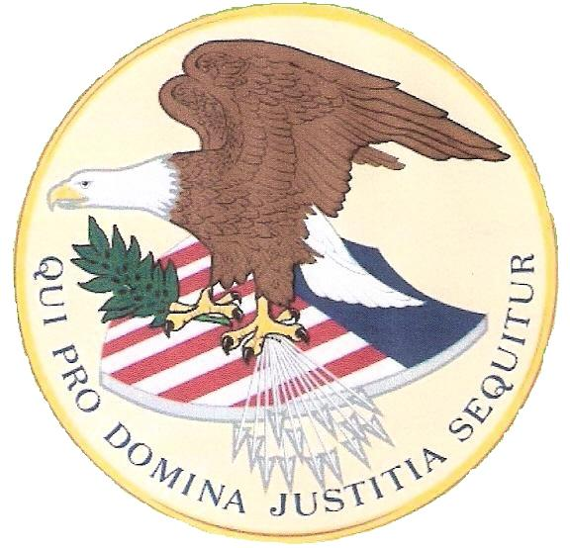
OFFICE OF A US EXECUTOR:
An ORDER to Terminate and Liquidate all DEAD ESTATE Contracts with IOWA.
To: Jim Mumford
State of Iowa – Regulator
Securities Administrator Insurance Division; Securities Bureau,
330 E. Maple Street,
Des Moines, IA 50319-0066
Subject: The US ESTATE of the “DEAD Commercial” PATRICK DEVINE;
(aka PATRICK P DEVINE, PAT DEVINE, PATRICK PAUL DEVINE)
Documents have been submitted to TERMINATE and LIQUIDATE all associated Contracts and Surety Policies held by the “DEAD Commercial” PATRICK DEVINE – US ESTATE per EIN # ____________ and UCC1 # ____________. This includes the IOWA Surety/Insurance Commercial Policies holding the “DEAD” US ESTATE asset Credits of which have been refused to be paid out to the Living Beneficiary. The US Executor is ORDERING You in your Office of REGULATOR to have the following IOWA Surety/Insurance accounts Liquidated and assets turned over; as their continued existence is an Act of Treason and Federal Charges will be filed, if not Honored. All Titles and Rights are to be expatriated and freed from all STATE fraudulent controls per the Law that protects the Rights of a Free Living Man. The originals or copies were previously submitted to IOWA State departments.
- STATE OF IOWA - PATRICK PAUL DEVINE "Drivers License" # ____________; a STATE Commercial Surety/Insurance Policy Contract for the Dead Estate to have insured "Driving" Privileges, even though the Dead cannot drive.
- STATE OF IOWA - PATRICK PAUL DEVINE "Voter Registration Card" # ____________; a STATE Commercial Surety/Insurance Leasing Contract for Shareholder "Voting" Privileges.
- STATE OF IOWA - Certificate of Title to a Vehicle - # ____________ and VIN # ____________; a STATE Commercial Surety/Insurance Policy Contract for the Dead Estate to have insured vehicle replacement protections, but has utilized forced Adhesion reinsurance contracts against the Secured Party.
- STATE OF IOWA - Certificate of Title to a Vehicle - # ____________ and VIN # ____________; a STATE Commercial Surety/Insurance Policy Contract for the Dead Estate to have insured vehicle replacement protections, but has utilized forced Adhesion reinsurance contracts against the Secured Party.
IRS Form 8806 has also been submitted by the US Executor to liquidate all IOWA and UNITED STATES Commercial Security/Surety Contracts with the DEAD and to transfer all assets under the “DEAD” PATRICK DEVINE – US ESTATE to a private US TRUST; as an Act of Impeachment because the US ESTATE has been found to be unworthy of holding Credit. No dead or debt currency or instruments of exchange (no checks) will be accepted only lawful cash or silver.
Delivery Information:
Post Route Box 8236, c/o 18463 -208th Avenue, Sigourney, Iowa
Phone contact # (641) 541-0035
Sign, Sealed and Submitted on February 23, 2013.
By the US Executor: _______________________________________
Patrick: of the family Devine

