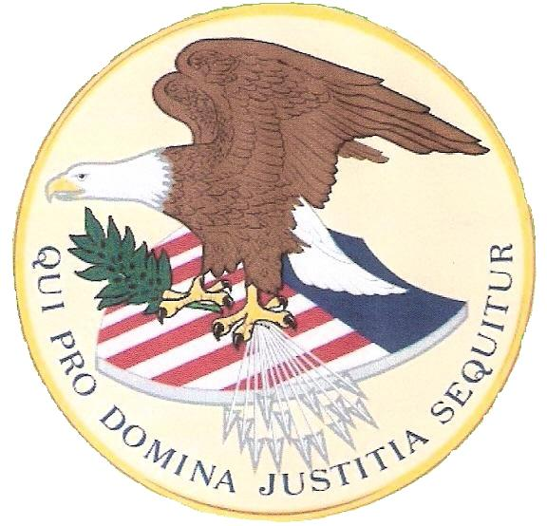
OFFICE OF the US EXECUTOR:
An ORDER to Transfer Assets for Tax obligations.
The US ESTATE of the “DEAD Commercial” PATRICK DEVINE; TIN #xxx-xx-xxxx
(aka PATRICK P DEVINE, PAT DEVINE, PATRICK PAUL DEVINE)
per EIN # ____________ and UCC1 # ______________.
IRS Form 8806 has also been submitted by the US Executor to EXECUTE all US ESTATE “United States Treasury - Trust Fund” Transfers to the “United States Treasury - Special Fund” a private US TRUST account per EIN # _____________; the Transfer is in compliance with the US ESTATE taxing requirements and will be reported per IRS Forms 3520. But in this case the transfer of $_________ is to be to the US Executor, as he is standing over both of the EIN established US ESTATE and US TRUST accounts. No dead or debt currency or instruments of exchange (no checks) will be accepted only lawful cash or silver.
US is “We the People” Standing Up Right of Age.
U.S. is the brand of the UNITED STATES organization of corporation controlled by “We the People”.
Delivery Information:
Post Route Box 8236, c/o 18463 -208th Avenue, Sigourney, Iowa
Phone contact # (641) 541-0035
Sign, Sealed and Submitted on February 23, 2013.
Ordered by the US Executor: _______________________________________
Patrick: of the family Devine

